Course1_12-21-2022

1. Welcome

1.1 Welcome
Notes:
Welcome to Periodic Client Reviews, Course 2: Preparing for Client Reviews. Select the Next button to begin, or select the Accessibility Support button to find out about the accessibility features built into this course.

Accessibility Support Layer: No audio.

https://www.istockphoto.com/photo/confident-businesswoman-sitting-at-desk-gm498323267-498323267

Accessibility Support (Slide Layer)
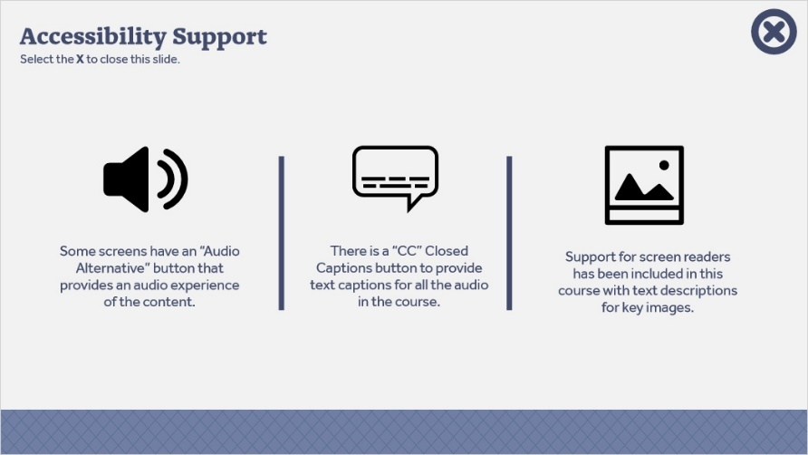

1.2 Review and Objectives
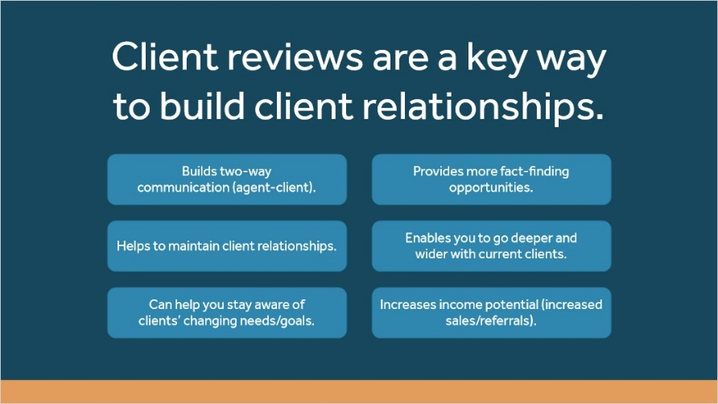
Notes:
(Text on screen with audio – benefits, and text animates to narration timing.)
This is the second course in the Periodic Client Review Series. In the first course, “Getting Started with Client Reviews,” you learned about the benefits of client reviews and how you can get started with your existing client size those relationships.

(Layer 1: 8R’s graphic animates onscreen – highlight where we are in the process.)
In this course, you will learn more about how to prepare for the Client Review –preparing information to gather and which questions to prepare ahead of time based on the Client’s profile.

https://www.istockphoto.com/photo/businesswoman-using-laptop-in-office-gm498323255-498323255

Layer 1 (Slide Layer)

1.3 Video Transition
Notes:
Let’s take a moment to connect with Sarah – a New York Life agent whom we were introduced to in the first course. Sarah has had a lot of success by making Client Reviews a regular part of her business strategy.
A colleague, Dennis, has approached Sarah for some tips for preparing for Client Reviews. Select the button to listen in.

Dialogue/video plays:

Dennis: Hi, Sarah – thank you for taking the time to meet. I’ve been prioritizing Client Reviews, but I see mixed results. Some clients aren’t interested, and with some clients, it seems like it’s just a Q and A session where I gather information. I need help. I hope you can share some of your experiences with me - tips? Best practices?

Sarah: Of course - I’m more than happy to help. One of the essential parts of the review is ensuring you’re prepared for it. What are you currently doing to prepare before you meet with the Client?

Dennis: Well – I schedule the appointment. I’ll look at some of the Client’s policy information, but I save most of the fact-finding for the review itself; when we’re face-to-face.

Sarah: While fact-finding happens during the conversation – you need to take some time to prepare – it sets you up to ask the right questions, which is better for you AND the Client. Why don’t you let me know when you have some time, and I can help you prepare for your following review?

Dennis: That would be great!

(Conversation fades)

Narrator debriefs/transition:
As you heard Sarah explain, preparing for the Client Review is a critical part of the review process. Let’s explore some steps you can take as an agent to prepare for Client Reviews effectively.

1.4 Agent Dennis - Option 1
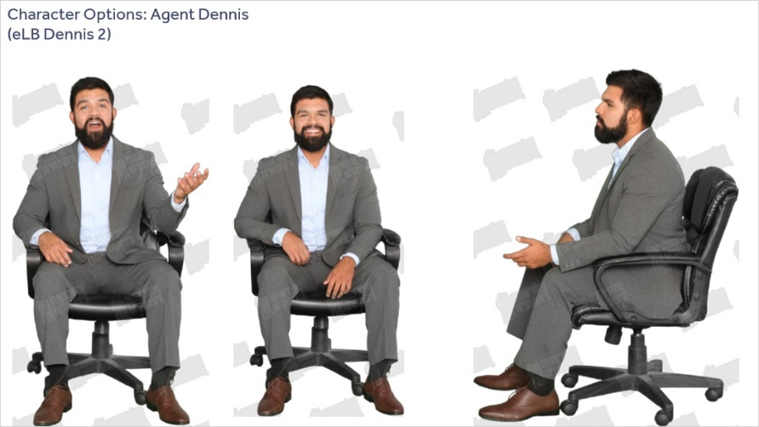
Notes:
Agent Dennis – Option 1

1.5 Agent Dennis - Option 2
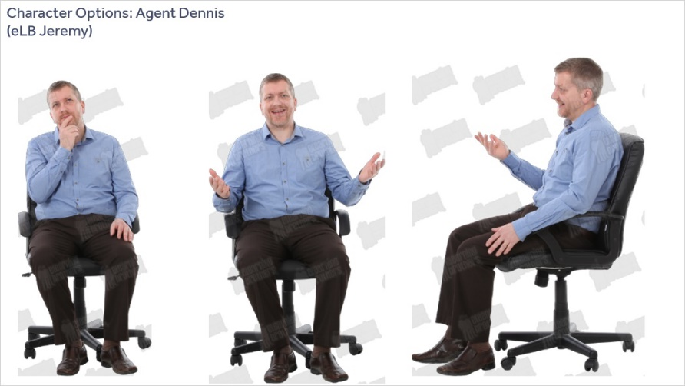
Notes:
Agent Dennis – Option 2
(eLB Character “Jeremy”)

2. Preparing for Client Reviews

2.1 How to Prepare for Client Reviews
Notes:
Transition slide, no audio.
https://www.istockphoto.com/photo/merging-business-with-the-online-world-gm598261008-102615625

2.2 Introduction to the Four Steps
Notes:

Description: Learner introduced to steps 1-4 and prompted to select each branch to the relevant content.

There are four recommended steps to prepare for Client Reviews.

Select each step to learn more.

https://www.istockphoto.com/photo/her-expert-abilities-always-take-her-further-gm1020498558-274160507

2.3 Review Records
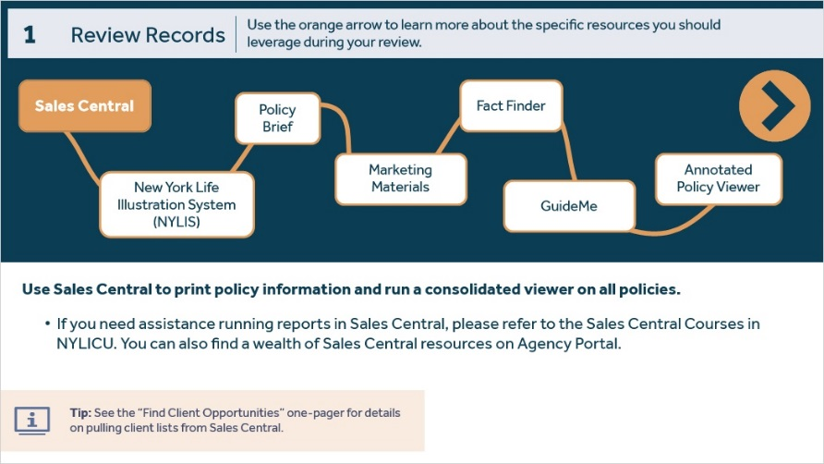
Notes:
The first step is to review client records to gather personal information and information regarding the Client’s current policies and financial goals. Use the arrow to learn more about the resources you should leverage during your review.

(No audio on individual layers.)

NYLIS - 1 (Slide Layer)
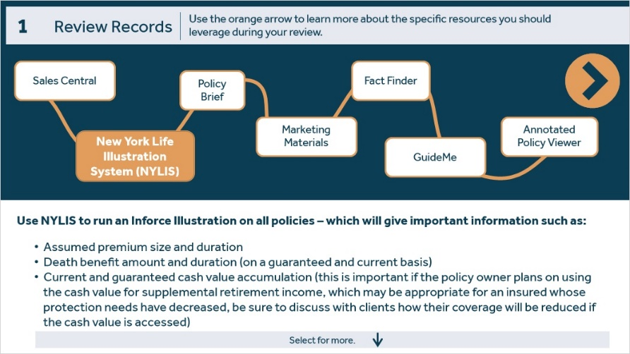

NYLIS - 2 (Slide Layer)
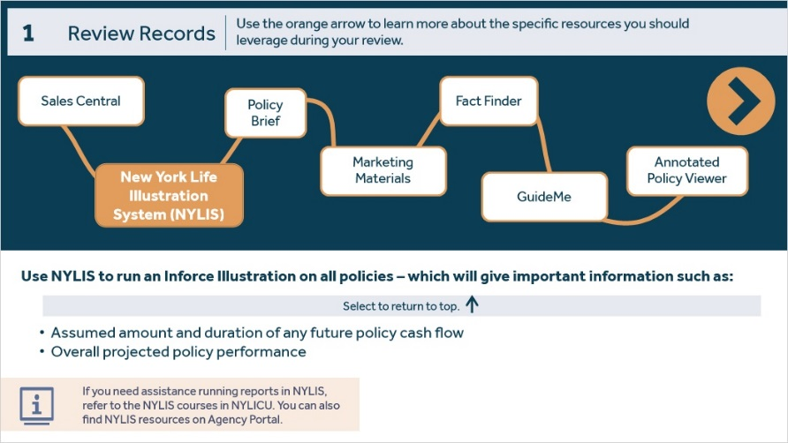

Policy Brief (Slide Layer)
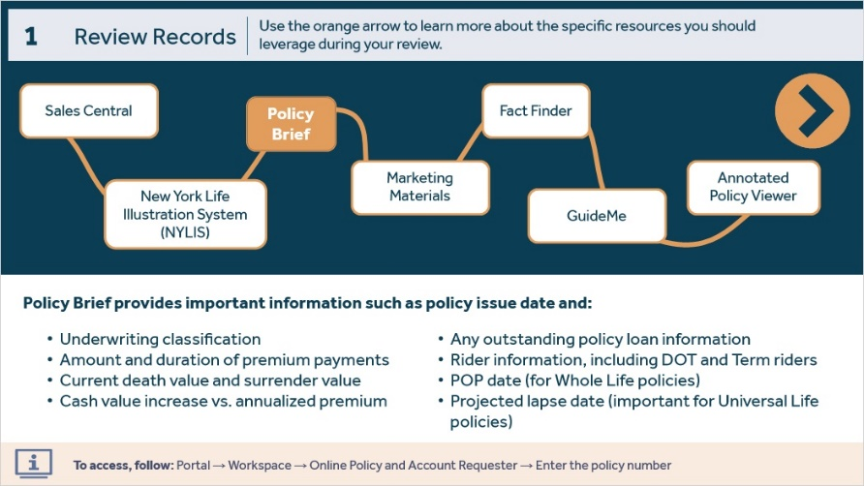

Marketing Materials (Slide Layer)
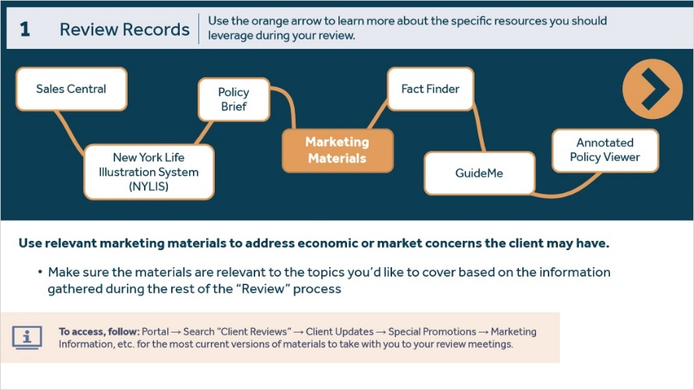

Fact Finder (Slide Layer)
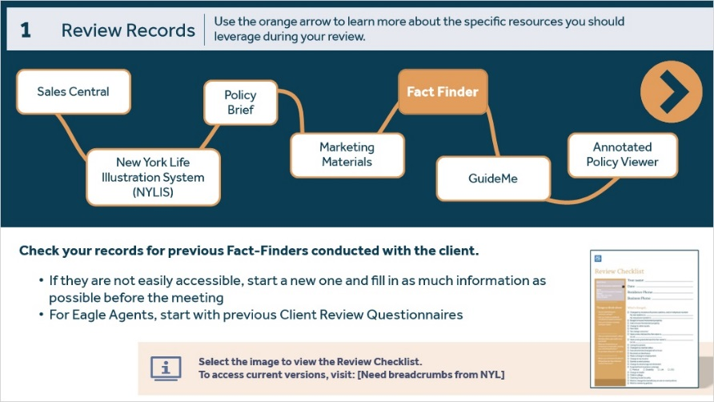

Review Checklist (Slide Layer)
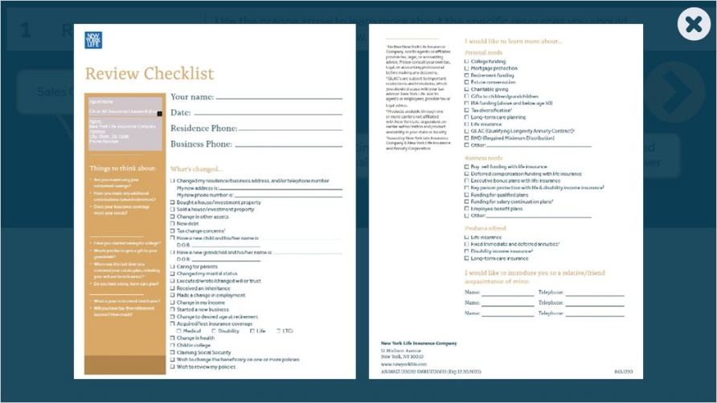

GuideMe (Slide Layer)
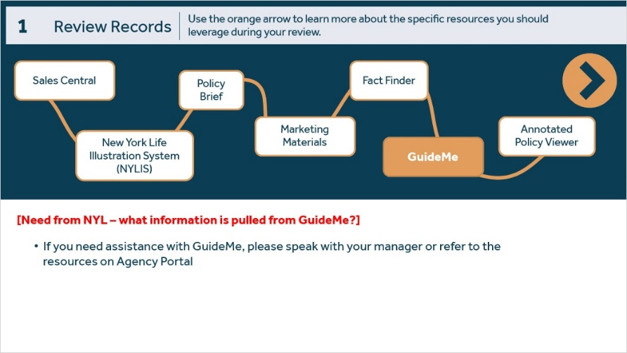

Annotated Policy Viewer (Slide Layer)
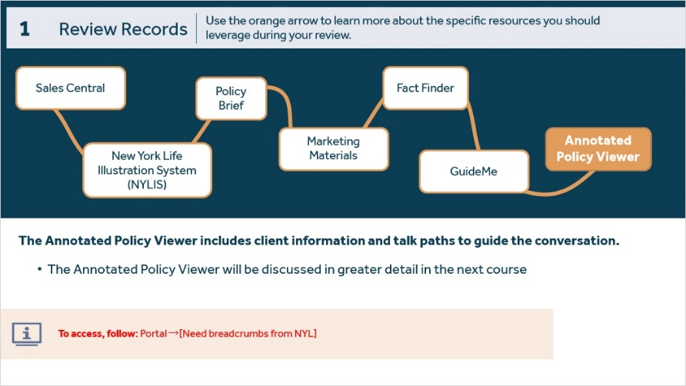

2.4 Gather Facts
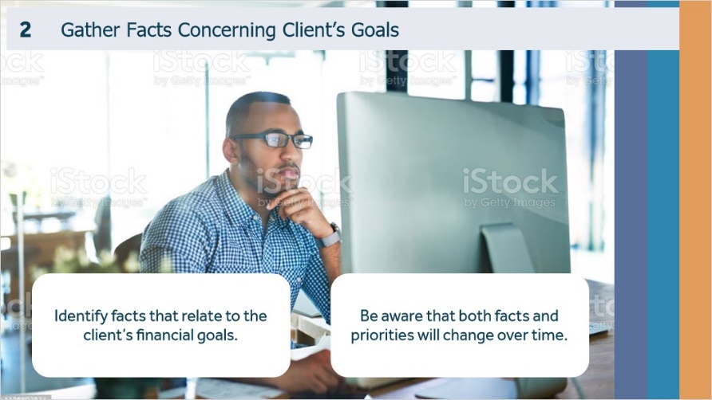
Notes:
After you have reviewed all available records, it’s time to gather and organize the most current facts concerning the Client’s goals.

2.5 Resources for Gathering Information
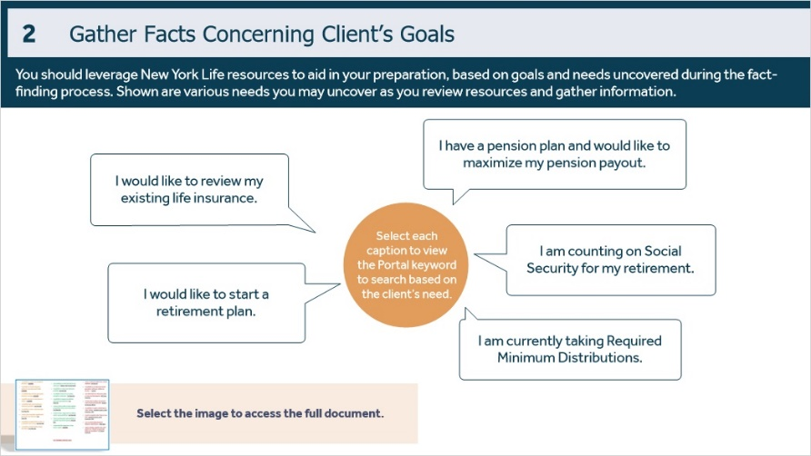
Notes:
Search Portal using the keywords underlined when working with the needs shown. Based on the identified goals, you should be prepared to address potential needs and answer questions. One resource to help with this is the “Checklist Training Colored Cheat Sheet,” – which provides sample needs associated with keywords to search in Portal.

(When selected – each caption shows the associated Keyword to search in Portal – answers are:

I would like to review my existing life insurance. guide
I would like to start a retirement plan. Tax Diversify
I am counting on Social Security for my retirement. Replace SS/ Income Needs
I am currently taking Required Minimum Distributions. RMD MAX
I have a pension plan and would like to maximize my pension payout. Pension Max

*NYL – If there are other ‘needs’ we want to include in the captions, let me know. This is based on the ”Checklist Training Colored Cheat Sheet” provided. I wasn’t sure if this was the correct placement/use.

Question for NYL – these were color-coded by column in the source materials, but there wasn’t a key that explained the differences. Is color coding necessary? If so – please clarify the intent.

2.6 Starter Questions and Talking Points
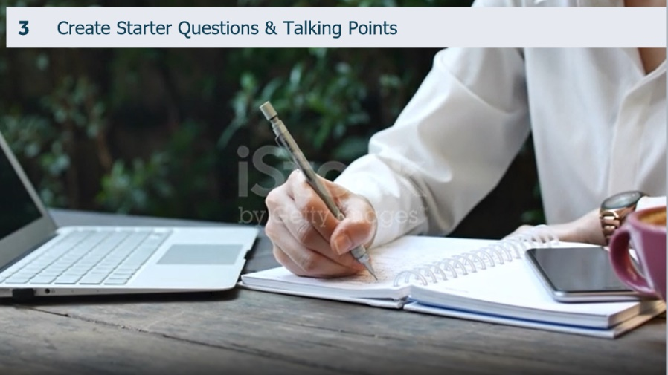
Notes:
Next, you should look at the big picture based on the information you’ve reviewed and the facts identified, to create a list of starter questions and topics to use during your discussion.

Proposed stock video – plays with narration:
https://www.istockphoto.com/video/hands-of-woman-writing-a-letter-gm1251548795-365282311
Video fades and tiles animate on screen (shown on next slide in Storyboard)

2.7 Starter Questions and Talking Points
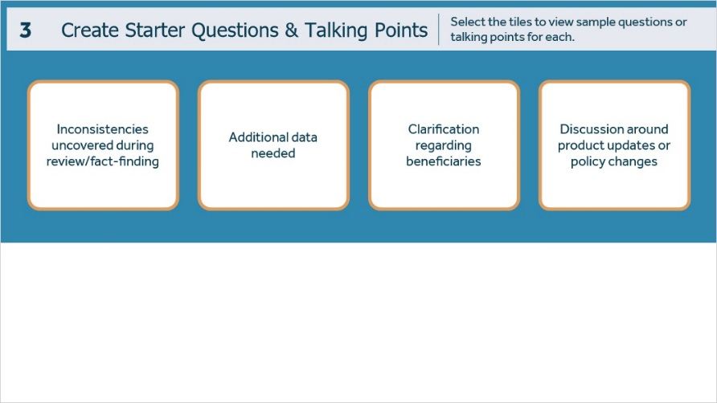
Notes:
Questions may pertain to inconsistencies you’ve noticed, missing data, clarification regarding beneficiaries, or discussion around product updates or policy changes.
Select each of the tiles to view sample questions for each.

Tile 1 (Slide Layer)
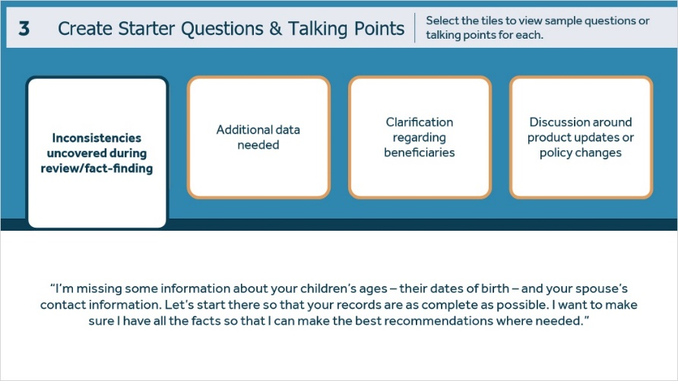

Tile 2 (Slide Layer)
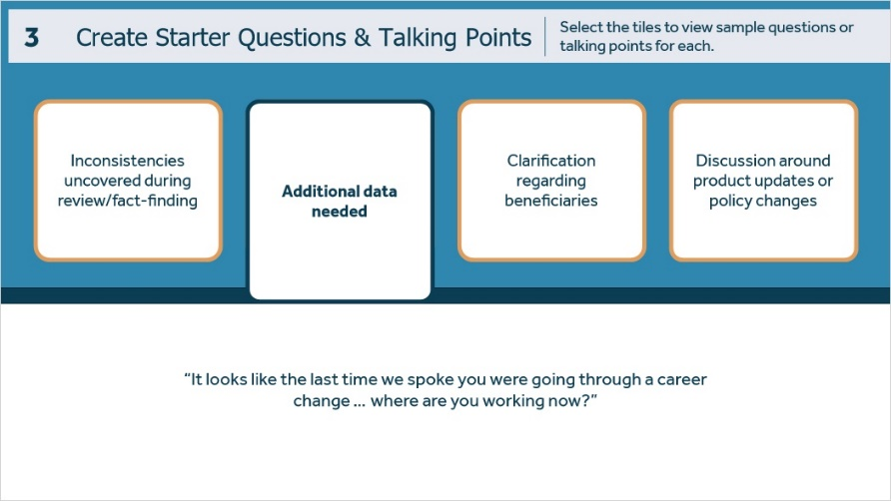

Tile 3 (Slide Layer)
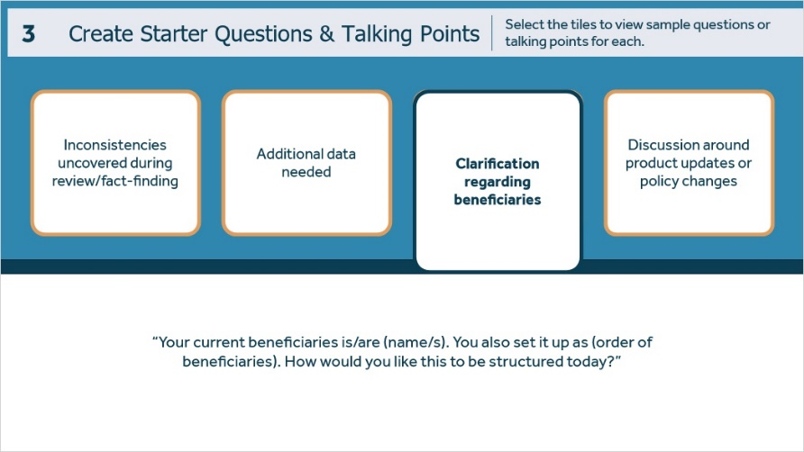

Tile 4 (Slide Layer)
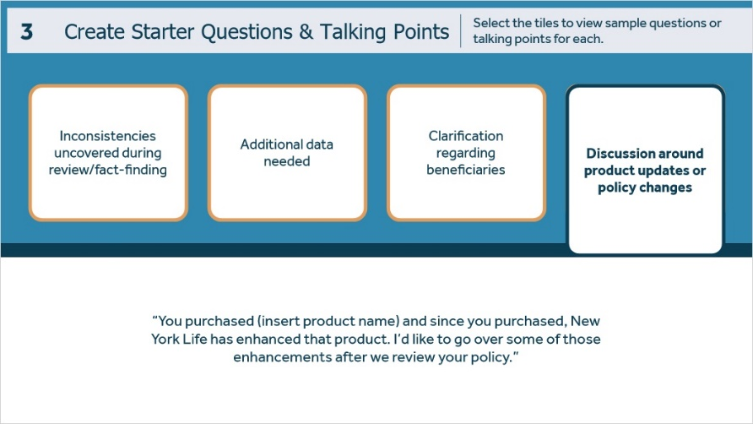

2.8 Goals and Questions Aligned to Life Stage
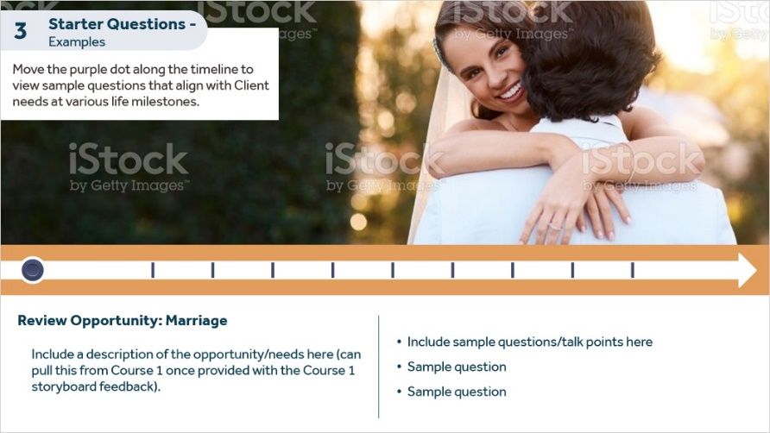
Notes:
Audio:
Considering goals and starter questions, it’s essential to consider the prospect’s life stage. Let’s review some sample financial goals and starter questions that align with the life stages you were introduced to in Course 1.

NYL – these are the milestones we use in Course 1. If this sounds okay – we will build this once we have the content/feedback from Course 1. (And we will need SME input re: what specific “Questions” we should align to each life stage.) We can build on the Course 1 exercise where we use the slider to discuss “opportunity/need based on life stage,” but here, we can add example questions they can prepare based on life stage.

Policy Anniversary - What has changed since we last met?
Term Conversion – How long do you need your life insurance?
Marriage
Birth of a child
New job/changing careers/promotion
Move/new house
Kids in college/empty nesters
Retirement
Post-retirement (Age 70 1/2)
Death of a spouse

2.9 Starter Questions - Practice Exercise Introduction
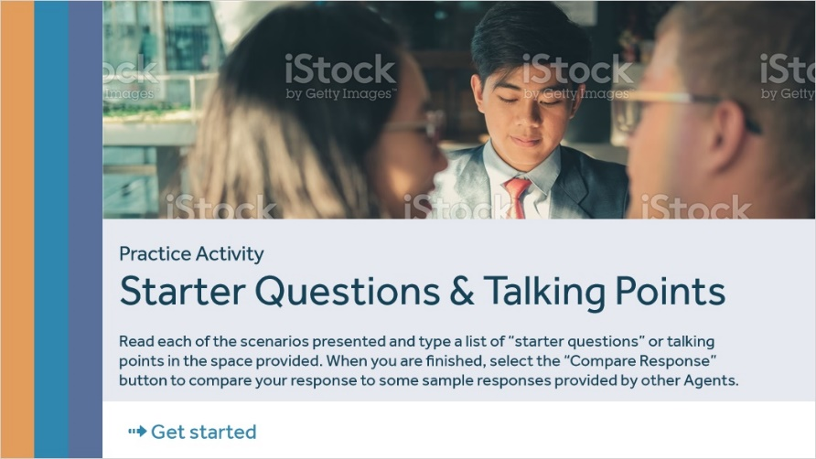
Notes:
Let’s take a moment for some practice. Read each scenario and type a list of “starter questions” or talking points in the space provided. When you are finished, select the “Compare Response” button to compare your response to some sample responses offered by other Agents.

NYL: Please provide feedback on this exercise// revise scenarios and sample questions as needed.

https://www.istockphoto.com/photo/couple-consulting-lawyer-about-buying-renting-house-car-insurance-broker-financial-gm1192980684-339155380

2.10 Practice Scenario 1
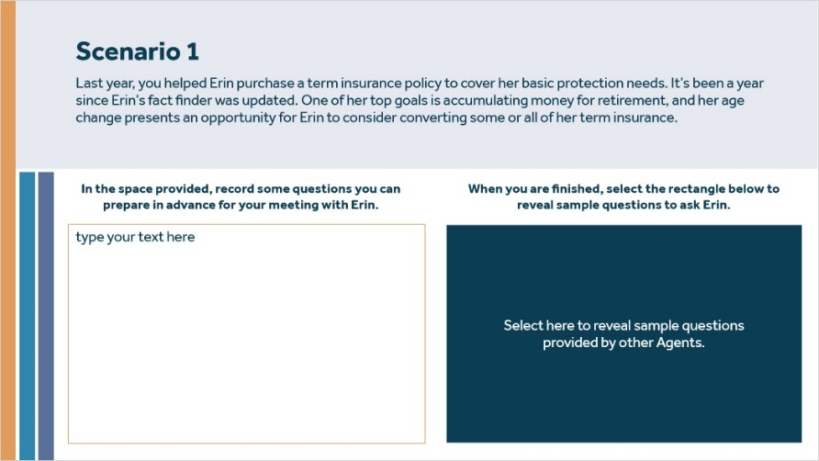
Notes:
No audio.

NYL: Please provide feedback on this exercise// revise scenarios and sample questions as needed.

Sample Questions (Feedback Layer) (Slide Layer)
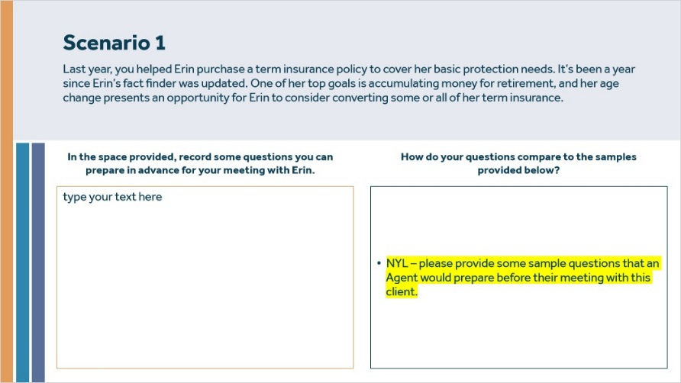

2.11 Practice Scenario 2
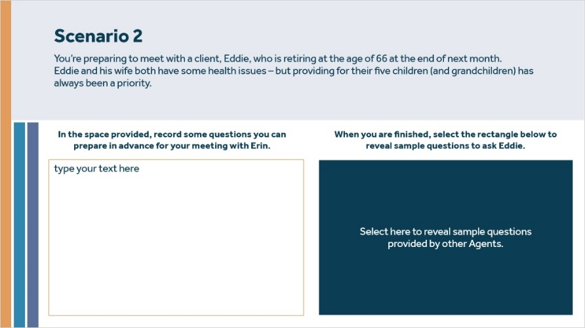
Notes:
No audio.

NYL: Please provide feedback on this exercise// revise scenarios and sample questions as needed.

Sample Questions (Feedback Layer) (Slide Layer)
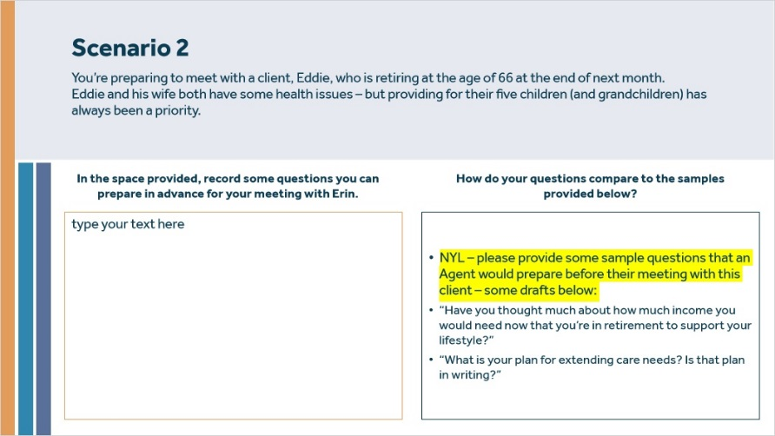

2.12 Practice Scenario 3
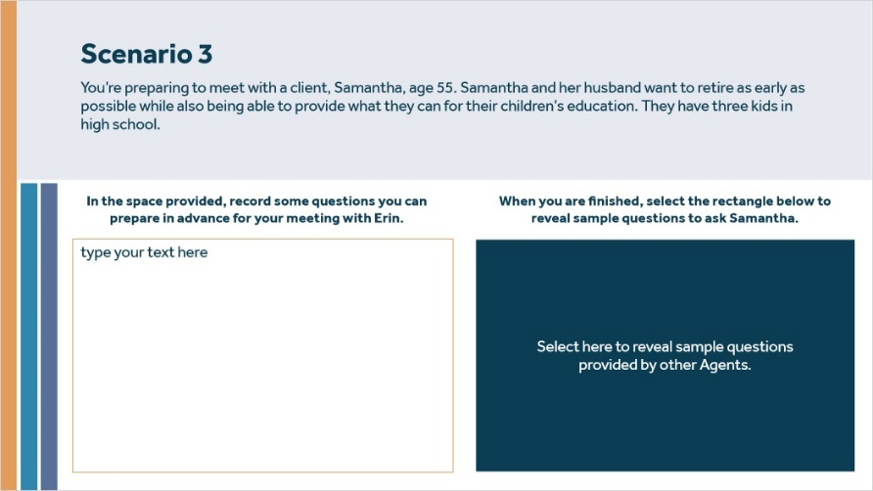
Notes:
No audio.

NYL: Please provide feedback on this exercise// revise scenarios and sample questions as needed.

Sample Questions (Feedback Layer) (Slide Layer)
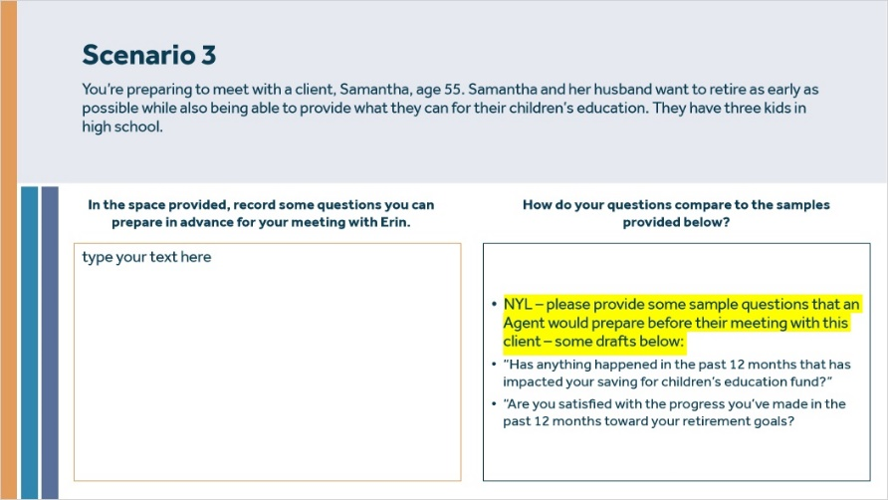

2.13 Create an Agenda
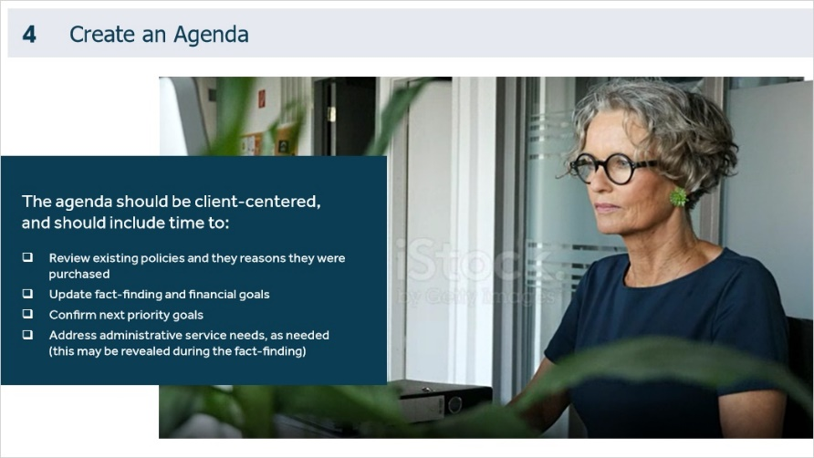
Notes:
After you have gathered all the facts and created a list of starter questions and topics, it’s time to prepare the agenda. The agenda should be client-centered and should include time to:
- Review existing policies and the reason they were purchased
- Update fact-finding and financial goals
- Confirming next priority goals
- Addressing administrative service needs, as needed (this may be revealed during the fact-finding).

https://www.istockphoto.com/video/mature-female-software-engineer-using-computer-gm972035536-264631720

3. Best Practices for Reaching Out

3.1 Instructions
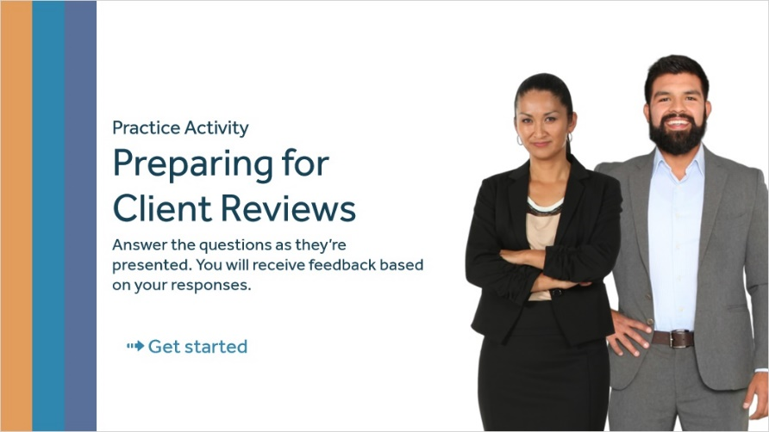
Notes:
Now that you have reviewed steps 1-4 let’s help agent Sarah walk through the steps with Dennis as he prepares for his meeting with a client, Will. During this practice, you’ll be presented with a series of questions, but first, let’s listen in as Dennis and Sarah begin their meeting.

3.2 Video Placeholder
Notes:
Dennis: Thanks again, Sarah, for agreeing to meet with me. I’m meeting with a client, Dennis, in a couple of days. It’s been over a year since I’ve connected with him. He and his wife Tasha are near retirement – and as far as I can remember, one of them was making a job change the last time we spoke. I need to get some updates there.

Sarah: I’m happy to help. We need to gather all the data to form the picture of current policies, current needs, and any questions or gaps we need to address upfront… Let’s begin by looking at their records.

(Video fade)

3.3 Question re: step 1
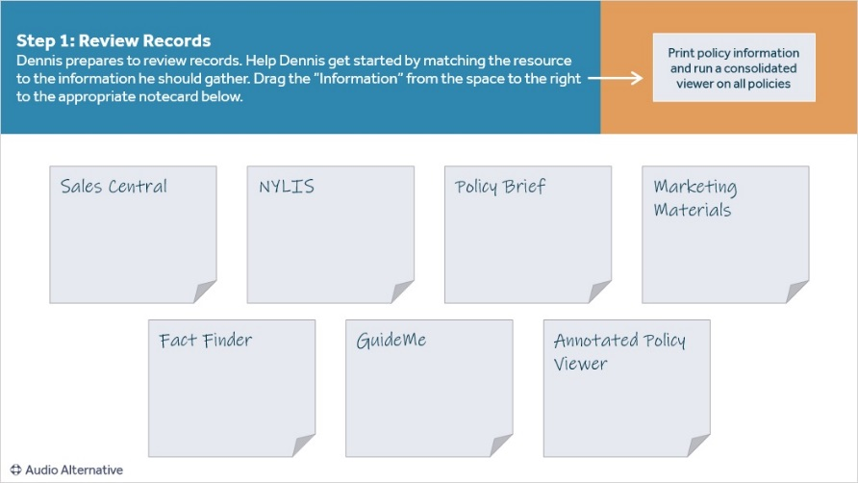
Notes:
Comment to New York Life: I’ve started the draft of this section but need NYL input to continue/finish. This is based on the proposed exercises in the course plan “Practice Activity.” NYL input/feedback is needed throughout (slides 3.3-3.6).

Drag and drop questions with audio alternative, no audio on the base layer or feedback layers. If the learner drops to the correct location, it will “stick.” If dropped to the incorrect location, it will bounce back.

NYL: Need input there – here are the current drag items and drop locations – please revise/edit as needed:

Sales Central – Print policy information and run a consolidated viewer on all policies
NYLIS – Run an Inforce Illustration on all approaches to review premium size and duration
Policy Brief – Review policy issue date, rider information, and (NYL – need input re: what they would get from the Policy Brief vs. the NYLIS Inforce Illustration? It seems like they cover the same things.)
Marketing Materials – Use to address current economic or market concerns the Client may have
Fact Finder - Use for gathering information with the Client – previous versions may be on record
GuideMe – Need input from NYL
Annotated Policy Viewer - Includes client information and talk paths to guide the conversation

Correct Feedback Layer (Slide Layer)
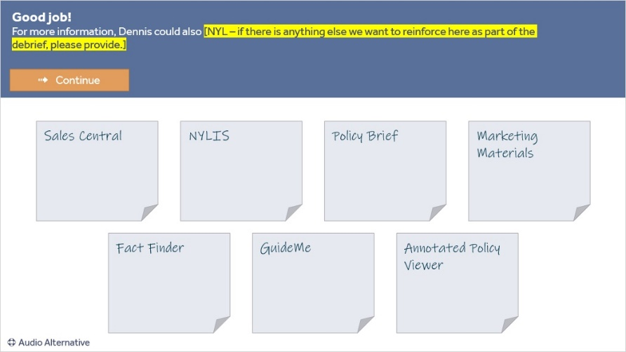

3.4 Question re: step 2
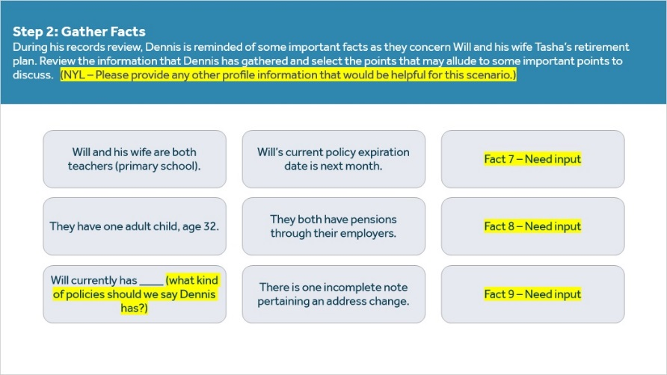
Notes:
No audio on this slide.
NYL – Need input/help with this step. The intention is that we 1.) List what “Dennis” could have noted during his records review, and 2.) Ask the learner to select the most pertinent items for follow-up or discussion.

Can you please edit/revise/add to the points on the screen (the nine boxes)? Then, if there is a specific rationale we should provide (universal to all or particular to each selection), can you please provide that?

3.5 Question re: step 3
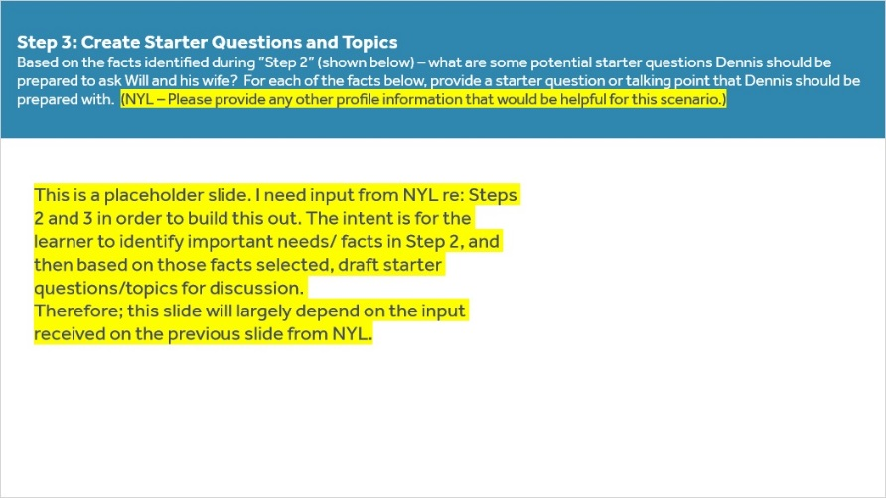
Notes:
This is a placeholder slide. The intent is for the learner to identify essential needs/ facts in Step 2 and then draft starter questions/topics for discussion based on those facts selected. I need input from NYL regarding Steps 2 and 3 to build this out.
Therefore, this slide will largely depend on the input received on the previous slide from NYL.

3.6 Question re: step 4
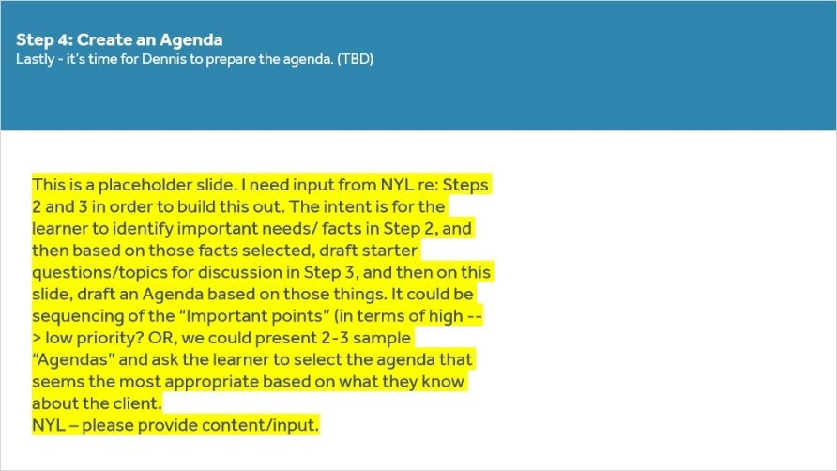
Notes:
This is a placeholder slide. I need input from NYL regarding Steps 2 and 3 to build this out. The learner intends to identify essential needs/ facts in Step 2 and then, based on those facts selected, draft starter questions/topics for discussion in Step 3. On this slide, draft an Agenda based on those things. Could it be the sequencing of the “Important points” (in terms of high --> low priority? OR, we could present 2-3 sample “Agendas” and ask the learner to select the most appropriate agenda based on what they know about the Client.
NYL – please provide content/input.

3.7 Video Placeholder
Notes:
Dennis: Wow – I feel MUCH better about meeting with Will and Tasha – knowing that they have some specific things we need to address makes me feel like our meeting has a real purpose – and, significantly – a real benefit for the Client. I’m using these practices moving forward.

Sarah: Absolutely! That’s precisely the point - it’s making sure you’re as best prepared as possible to truly address the Client’s needs and serve as an advisor. When the Client feels that you’re invested in the relationship, they’re more likely to be open to discussions long-term. I’m so glad I could help – if you need anything else, don’t hesitate to reach out.

(Video fade)

4. Summary and Conclusion

4.1 Testimonial
Notes:
What did you think about Dennis’s preparation for his client review? How confident are you in your ability to implement those same practices?

By making client reviews, and preparing for Client reviews a priority in your business, you are maximizing your role as a trusted agent – someone fully attuned to the Client’s changing needs, regardless of their life stage.

In the next course, you will learn more about the review conversation – including best practices and talk paths.

https://www.istockphoto.com/photo/smiling-african-american-financial-advisor-working-in-her-office-gm1185460637-334102161

4.2 Course Completion
(True/False, 10 points, unlimited attempts permitted)
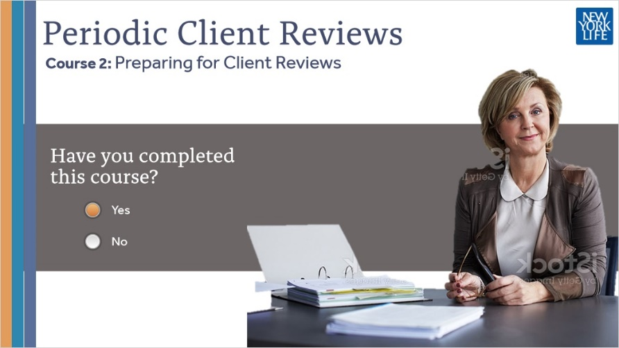
Correct | Choice
X | Yes
 | No
Feedback when incorrect:
You must acknowledge that you have completed this course to receive credit.

Notes:
No audio.
Stock photo ID:1323455410

Correct (Slide Layer)

Incorrect (Slide Layer)

Try Again (Slide Layer)

4.3 Resources
Notes:
For more information, visit the ________ page on Agency Portal. Here, you can find resources to prepare for client reviews to maximize opportunities for you and your clients. [Need breadcrumbs from NYL.]
https://www.istockphoto.com/photo/attractive-woman-working-in-office-on-laptop-gm1283955442-381236812

https://www.istockphoto.com/photo/quality-control-certification-checked-guarantee-of-standard-gm1282804749-380424412

4.4 Results Slide
Notes:
Congratulations! You have completed Periodic Client Reviews Course 2: Preparing for Client Reviews

