 |  | OST
Topic 1: Inventory
1 |  | What Is Inventory?  Inventory is tangible property that is:  - held for sale in the normal course of business, or  - used to produce goods or services for sale  Inventory is reported on the balance sheet as a current asset, as it is normally used or converted into cash within one year or by the next operating cycle. The types of inventory normally held depend upon the characteristics of the business.  Select each image for more information.  Image 1:  Merchandisers (wholesale or retail businesses)  Merchandisers hold the merchandise inventory goods (or merchandise) held for resale in the normal course of business. The goods are usually acquired in a finished condition and are ready for sale without further processing.  Image 2:  Manufacturing businesses  Manufacturing businesses hold three types of inventory:  - Raw materials inventory—  These are items acquired for the purpose of processing into finished goods.  - Work-in-process inventory—  These are goods in the process of being manufactured but not yet completed. When created or produced, they become finished goods inventory.  - Finished goods inventory—  These are goods that are ready for sale.
Image ID:

Alt Text:
 |  | Sample Template: Text with Image 1
2 |  | Inventory Costs  Goods in inventory are initially recorded at cost. Inventory cost is the sum of all the costs incurred in bringing an article to a saleable condition and location. The amount recorded should include the invoice price to be paid plus other purchase costs, such as cost of purchasing item, freight charges to deliver the items to the warehouse (freight-in) and inspection and preparation costs. Any purchase returns and allowances or purchase discounts taken are subtracted.  In general, the company should cease accumulating purchase costs when the raw materials are ready for use, or when the merchandise inventory is ready for shipment.  Any additional costs related to selling the inventory to the dealers, such as marketing department salaries and dealer training sessions, are incurred after the inventory is ready for use. These costs should be included in selling, general, and administrative expenses in the period when they are incurred.  For merchandisers (wholesalers and retailers), this is how inventory cost flows:  - When merchandise is purchased, the merchandise inventory account increases.  - When goods are sold, cost of goods sold increases and merchandise inventory decreases.  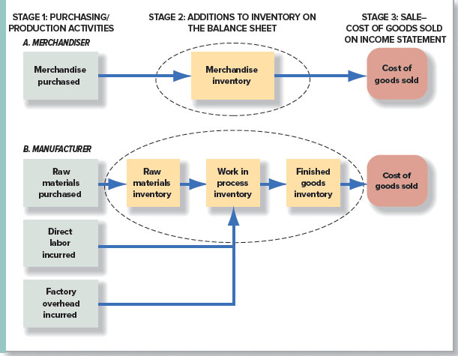
Image ID:

Alt Text:
Sample Template: Text with Image 1

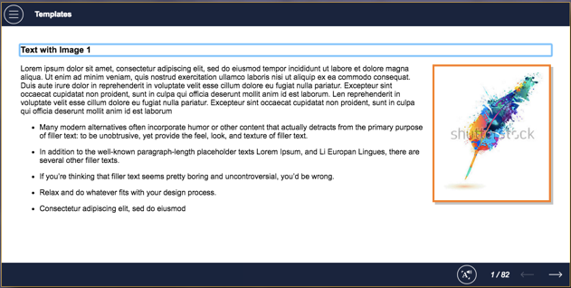

3 |  | Managing Inventory  The primary goals of inventory management are:  - An adequate inventory of high-quality goods readily available for all customers. Inadequate amounts of hot-selling items cause stock-outs that lead to lost sales revenue and decreased customer satisfaction. Low-quality inventory of goods leads to customer dissatisfaction causing a decline in future sales.  - Minimal inventory costs such as production, storage, obsolescence, and financing. Too much inventory of slow-selling goods increases storage costs as well as interest costs on short-term borrowings used to finance the purchases. It may even lead to losses if the merchandise cannot be sold at normal prices.
Image ID: Royalty-free stock photo ID: 256145128
Alt Text:
 |  | Sample Template: Text with Image 1
4 |  | The Inventory Management Process  The accounting system plays three roles in the inventory management process.  - The system must provide accurate information for preparation of periodic financial statements and tax returns.  - It must provide up-to-date information on inventory quantities and costs to facilitate ordering and manufacturing decisions.  - As inventories are subject to theft and other forms of misuse, the system must also provide information needed to help protect these important assets.  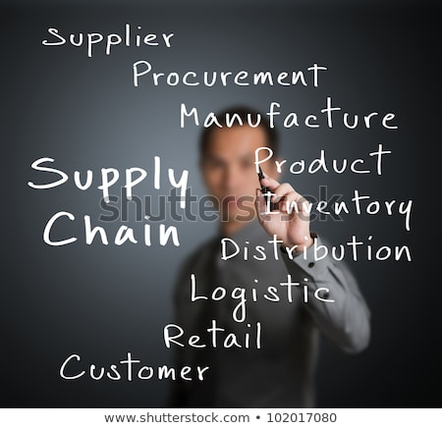
Image ID: Royalty-free stock photo ID: 102017080
Alt Text:
 |  | Sample Template: Text with Image 1
5 |  | The use of raw materials in the manufacturing process is reported as an operating expense on the income statement.  Select the correct answer.  - True  - False  Incorrect response  That’s not correct.  Raw materials become part of work-in-process inventory.  Correct response  Well done!  Raw materials become part of work-in-process inventory.
Image ID:
Alt Text:
Sample Template: CYU_TrueFalse
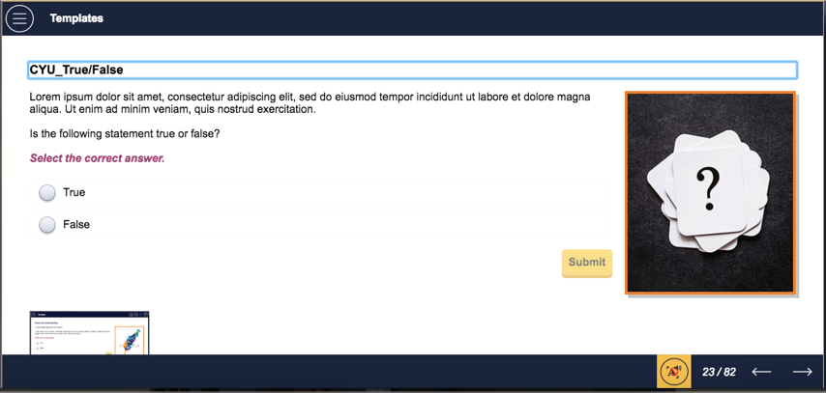
Topic 2: Inventory Methods
6 |  | Determining Cost Of Goods  There are four common inventory costing methods used for determining cost of goods sold. These methods help in assigning dollar amount to goods available for sale between ending inventory and cost of goods sold.  Remember that the cost assigned to the goods does not change the amount of items in the inventory or items sold. It is a reflection of assigning cost to the inventory. Selecting an inventory costing method is not based on the physical flow of goods on and off the shelves. The cost of goods keeps fluctuating with time; it differs between the time the goods were bought, to the time they are sold. Companies, therefore, give the goods an assumed (average) cost and use that to assign cost to the inventory. That is why we use the term cost flow assumptions. It is useful represent inventory cost flow assumptions as a bin, or container. Inventory costing methods can then be seen as flows of inventory in and out of the bin.  Select each image for more information.  Image 1:  Specific identification  This method identifies individual items that remain in inventory or are sold, and requires keeping track of the purchase cost of each item.  Image 2:  First-in, first-out (FIFO)  The first-in, first-out method, or FIFO, assumes that the earliest goods purchased (the first ones in) are the first goods sold, and the last goods purchased are left in ending inventory. This method assumes that the inventory costs follow a certain flow.  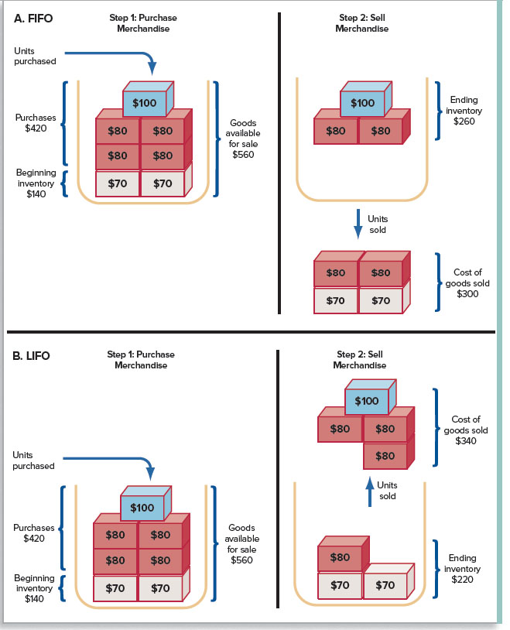  Image 3:  Last-in, first-out (LIFO)  The last-in, first-out method, or LIFO, assumes that the most recently purchased goods (the last ones in) are sold first and the oldest units are left in ending inventory. This method assumes that the inventory costs follow a certain flow.  Image 4:  Average cost  The average cost method (weighted average cost method) uses the weighted average unit cost of the goods available for sale for both cost of goods sold and ending inventory. This method assumes that the inventory costs follow a certain flow.  Note to development team: I have cut the image in half to show the relevant parts in relevant pop-up section. Could you please add consistent borders to both? Thank you.  Note to development team: And, cover the A and B in front of FIFO and LIFO on top-left so they are not visible.
Image ID:

Alt Text:
 |  | Sample Template: Flipcard 1
7 |  | Lauer Corporation uses the periodic inventory system, and has provided the following information about one of its laptop computers:  Date Transaction Number of Units Cost per Unit  1/1 100 $800  5/5 Purchase 200 $900  8/10 Purchase 300 $1,000  10/15 Purchase 200 $1,100  During the year, Lauer sold 750 laptop computers. What would the ending inventory be, using the LIFO cost flow assumption?  Select the correct answer.  - $40,000  - $45,500  - $55,000  - $60,000  First incorrect response  That’s not correct. Please try again.  Second incorrect response  That’s not correct.  Ending inventory = $800 × 50 = $40,000  Correct response  Well done!  Ending inventory = $800 × 50 = $40,000
Image ID:
Alt Text:
Sample Template: CYU_MCQ_1
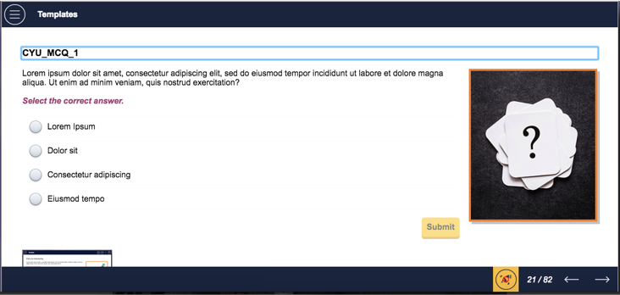

Topic 3: Inventory Turnover Ratio
8 |  | Calculating Inventory Turnover  The inventory turnover ratio shows the number of times the average inventory was produced and sold during a given period of time. A higher ratio indicates that the inventory moves quickly through the production process to the end customer, reducing storage and obsolescence costs.  This saving can be invested to earn interest income or reduce borrowing, which reduces interest expense. Efficient purchasing and production techniques such as just-in-time inventory and high product demand cause this ratio to be high. Analysts and creditors keep a sharp eye over the inventory turnover ratio, as a sudden decline indicates that the company faces a drop in demand or that there may be other issues in production management.  Net decrease in inventory for a given time period indicates that sales of existing inventory exceed purchases of new inventory. Therefore, the decrease must be added in computing cash flows from operations. When a net increase in inventory for the period occurs, the opposite is true.
Image ID:
Alt Text:
 |  | Sample Template: Accordian 2
9 |  | Tinker's cost of goods sold in the year of sale (2016) was $750,000, and 2015 cost of goods sold was $770,000. The inventory at the end of 2016 was $188,000 and at the end of 2015 the inventory was $208,000.  Tinker's inventory turnover during 2016 was closest to which number?  Select the correct answer.  - 3.79  - 3.99  - 3.84  - 3.89  First incorrect response  That’s not correct. Please try again.  Second incorrect response  That’s not correct.  Inventory turnover = Cost of goods sold ÷ Average inventory = $750,000 ÷ [($188,000 + $208,000) ÷ 2] = 3.79  Correct response  Well done!  Inventory turnover = Cost of goods sold ÷ Average inventory = $750,000 ÷ [($188,000 + $208,000) ÷ 2] = 3.79
Image ID:
Alt Text:
 |  | Sample Template: CYU_MCQ_1
Topic 4: Internal Control Of Inventory
10 |  | Managing Inventory  Many factors may affect inventory well-being, which directly affects a company’s financial health. For example, after cash, inventory is the asset most vulnerable to theft. Also, inefficient management of inventory adds to the overall cost, with stock-outs or overstock situations affecting the profitability of most companies. As a consequence, a number of control features focus on safeguarding inventories and providing up-to-date information for management decisions.  Some of these control features are:  - Separation of responsibilities for inventory accounting and physical handling of inventory  - Theft- and damage-proof storage of inventory  - Giving inventory access to authorized employees only  - Creating and maintaining efficient and up-to-date inventory  - Comparing perpetual records to periodic physical counts of inventory
Image ID: Royalty-free stock photo ID: 129636254
Alt Text:
 |  | Sample Template: Text with Image 1
11 |  | Which of the following is not a reason for having controls to safeguard inventories?  Select the correct answer.  - Protecting inventory items from theft  - Avoiding stock-outs from not having enough inventory on hand  - Reducing costs of maintaining the LIFO reserve  - Keeping track of overstocked items  First incorrect response  That’s not correct. Please try again.  Second incorrect response  That’s not correct.  Safeguarding inventory requires controls for the care of physical goods. The cost of maintaining the LIFO Reserve is an accounting cost, not a safeguard. Maintaining the Reserve is the actual control.  Correct response  Well done!  Safeguarding inventory requires controls for the care of physical goods. The cost of maintaining the LIFO Reserve is an accounting cost, not a safeguard. Maintaining the Reserve is the actual control.
Image ID:
Alt Text:
 |  | Sample Template: CYU_MCQ_1
Topic 5: Long-lived Assets
12 |  | Types Of Assets  One of the major challenges managers of most businesses face is forecasting the company’s long-term productive capacity—that is, predicting the amount of plant and equipment it will need. If managers underestimate the need, the company will not be able to produce enough goods or services to meet demand, and will miss an opportunity to earn revenue. On the other hand, if they overestimate the need, the company will incur excessive costs that will reduce its profitability. A lot of it has to do with how the company manages its long-lived assets. It is, therefore, important to be familiar with the life cycle of long-lived assets, as well as their acquisition, use, and disposal.  Long-lived assets are those that a company expects to retain for more than one year, or for more than one accounting period. These assets, listed as noncurrent assets on the balance sheet, have a huge impact on a company’s productive capacity. There are two types of long-lived assets.  Select each image for more information on the two types of long-lived assets.  Image 1:  Tangible Assets  Tangible assets have physical substance: they can be touched. The three kinds of long-lived tangible assets are:  - Land used in operations  - Buildings, fixtures, and equipment used in operations (Note: land, buildings, fixtures, and equipment are also called property, plant, and equipment or fixed assets.)  - Natural resources used in operations  Image 2:  Intangible Assets  Intangible assets are also long-lived assets, but without any physical presence. Examples are patents, copyrights, franchises, licenses, and trademarks.
Image ID:

Alt Text:
 |  | Sample Template:
Topic 6: Depreciation Concepts
13 |  | Understanding Depreciation  Except for land, which is considered to have an unlimited life, a long-lived asset with a limited useful life, such as an airplane, represents the prepaid cost of a number of future services or benefits. According to the expense principle, part of an asset’s cost should be assigned as an expense during the period in which revenues are generated by its use.  Students are often confused by the concept of depreciation as used by accountants. In accounting, depreciation is a process of cost allocation, and not a process to determine an asset’s current market value or worth. When an asset is depreciated, the remaining balance sheet amount usually does not represent its current market value. On balance sheets subsequent to acquisition, the undepreciated cost is not measured on a market or fair value basis. An adjusting journal entry is needed at the end of each period to reflect the use of buildings and equipment for the period.
Image ID:

Alt Text:
 |  | Sample Template: Text with Image 1
14 |  | Depreciation Expense  Depreciation Expense is the account in the income statement under which the amount of depreciation is recorded during each period.  Accumulated Depreciation is the contra-account in the balance sheet under which the amount of depreciation expense accumulated since the acquisition date is reported. It is deducted from the related asset's cost.  Net Book Value or Carrying Value is the net amount on the balance sheet. The Net Book Value (or Carrying Value) of a long-lived asset is its acquisition cost,less the accumulated depreciation from the acquisition date to the balance sheet generation date.  To calculate depreciation expense, three amounts are required for each asset:  - Acquisition cost  - Estimated useful life to the company  - Estimated residual (or salvage) value at the end of the asset’s useful life to the company
Image ID:
Alt Text:
 |  | Sample Template:
15 |  | Tangible long-lived productive assets differ from intangible long-lived productive assets. Tangible assets have a physical presence, whereas intangible assets do not have any physical presence.  Select the correct answer.  - True  - False  Incorrect response  That’s not correct.  Tangible assets have physical presence, whereas intangible assets do not have a physical presence.  Correct response  Well done!  Tangible assets have physical presence, whereas intangible assets do not have a physical presence.
Image ID:
Alt Text:
 |  | Sample Template: CYU_TrueFalse
Topic 7: Depreciation Methods
16 |  | Types Of Depreciation Methods  There are many depreciation methods. There are numerous types of industries, and each has a wide range of assets it owns. This prevents any standardization or generalization of a cost allocation method. There are, therefore, several depreciation methods, accepted across industries, that match the depreciation expense with generated revenues for a given time period or financial cycle. There are also different methods for specific assets or groups of assets. Managers and accountants, once they select a particular method, then need to apply it consistently over time for better financial information comparability.  Select each image for more information.  Image 1:  Straight-line Depreciation Method  Straight-line depreciation method is the most common method, used by more than 98% of companies for many or all of their assets. Under the straight-line method, an equal portion of an asset’s depreciable cost is allocated to each accounting period over its estimated useful life.  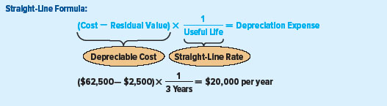  Image 2:  Units-of-production Depreciation Method  The units-of-production depreciation method relates depreciable cost to total estimated productive output. The formula for estimating annual depreciation expense under this method is as follows:  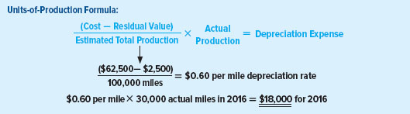  Image 3:  Declining-balance Depreciation Method  This method is used when an asset is considered more efficient or productive when it is new. A higher depreciation expense is matched with higher revenues in the early years of an asset’s life, and a lower depreciation expense is matched with lower revenues in the later years. It can, therefore, also be called an Accelerated Depreciation method. Accelerated methods are seldom used for financial reporting purposes. The one most commonly used is the Declining-balance method.  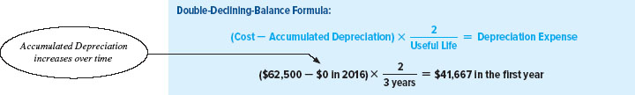
Image ID:
Alt Text:
Sample Template: Flipcard 1
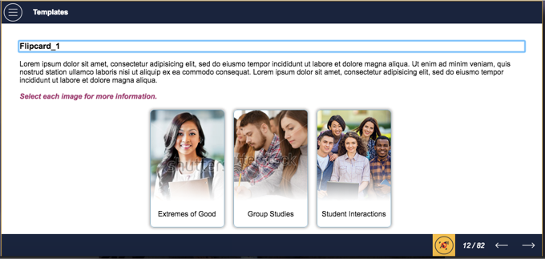

17 |  | A company plans to depreciate a new building using the double declining-balance depreciation method. The building cost $800,000. The estimated residual value of the building is $50,000 and it has an expected useful life of 25 years.  What is the building's book value at the end of the first year?  Select the correct answer.  - $736,000  - $768,000  - $686,000  - $690,000  First incorrect response  That’s not correct. Please try again.  Second incorrect response  That’s not correct.  Year 1 depreciation expense = $64,000 = $800,000 × 2/25.  Book value at the end of Year 1 = $736,000 = $800,000 – $64,000.  Correct response  Well done!  Year 1 depreciation expense = $64,000 = $800,000 × 2/25.  Book value at the end of Year 1 = $736,000 = $800,000 – $64,000.
Image ID:
Alt Text:
 |  | Sample Template: CYU_MCQ_1
Topic 8: Intangible Assets And Natural Resources
18 |  | Cost Allocation Of Intangible Assets  Intangible assets are increasingly important resources for organizations. An intangible asset, like any other asset, has value because of certain rights and privileges often conferred by law on its owner. Unlike tangible assets such as land and buildings, intangible assets have no material or physical substance. Instead, the majority of intangible assets are usually represented by a legal document. The most common types of intangible assets are as follows:  Goodwill (recognized in a business combination)  Trademarks  Copyrights  Most companies do not estimate a residual value for their intangible assets. The cost allocation of an intangible asset that has a definite life, is done on a straight line basis. This process is called amortization, and it is done over a period of time. Amortization expense is included on the income statement for each period. The intangible assets are reported as a cost less accumulated amortization on the balance sheet.  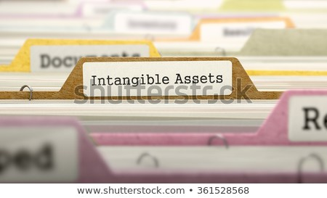
Image ID: Royalty-free stock illustration ID: 361528568
Alt Text:
 |  | Sample Template: Text with Image 1
19 |  | Goodwill is recorded only when an existing company is bought by another company and the purchase price exceeds the fair value of the purchased company's net assets.  Select the correct answer.  - True  - False  Incorrect response  That’s not correct.  Goodwill is recognized when the amount paid for an existing company exceeds the company's assets at fair value.  Correct response  Well done!  Goodwill is recognized when the amount paid for an existing company exceeds the company's assets at fair value.
Image ID:
Alt Text:
 |  | Sample Template: CYU_TrueFalse
20 |  | Cost Allocation Of Natural Resources  When natural resources such as mineral deposits, timber tracts, oil, and gas are acquired or developed, they are recorded in conformity with the cost principle. As a natural resource is used up, its acquisition cost must be apportioned among the periods in which revenues are earned in conformity with the expense principle. The term “depletion” describes the process of allocating a natural resource’s cost over the period of its exploitation. The units-of-production method is often applied to compute depletion.  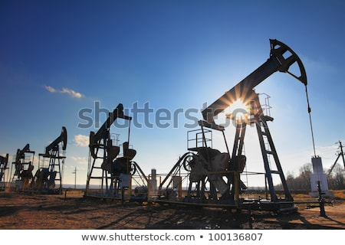
Image ID: Royalty-free stock photo ID: 100136807

Alt Text:
 |  | Sample Template: Text with Image 1
21 |  | During 2016, a company purchased a mine at a cost of $3,000,000. The company spent an additional $600,000 getting the mine ready for its intended use. It is estimated that 300,000 tons of mineral can be removed from the mine and the residual value of the mine will be $600,000. During 2016, 45,000 tons of mineral were removed from the mine and 35,000 tons were sold.  Which of the following statements is correct with respect to the accounting for the mine?  Select the correct answer.  - The 2016 net income decreased $450,000 as a result of the mining during the year.  - The book value of the mine decreased $350,000 during 2016.  - The inventory of minerals was $450,000 at December 31, 2016.  - The 2016 cost of goods sold was $350,000.  First incorrect response  That’s not correct. Please try again.  Second incorrect response  That’s not correct.  Depletion rate per ton = $10 = ($3,000,000 + $600,000 - $600,000) ÷ 300,000 tons.  Cost of goods sold = $350,000 = $10 × 35,000 tons.  Correct response  Well done!  Depletion rate per ton = $10 = ($3,000,000 + $600,000 - $600,000) ÷ 300,000 tons.  Cost of goods sold = $350,000 = $10 × 35,000 tons.
Image ID:
Alt Text:
 |  | Sample Template: CYU_MCQ_1
Problem Statements
22 |  | Problem Statement 1: Manufacturing Inventory  What are the components of manufacturing inventory?  Select the Tip icon to help you find the solution.  Tip 1:  Please read pages 335–337 in the textbook.  Tip 2:  Raw materials inventory, work-in-process inventory, finished goods inventory.  Tip 3:  xxx
Image ID:
Alt Text:
Sample Template: Scenario_1
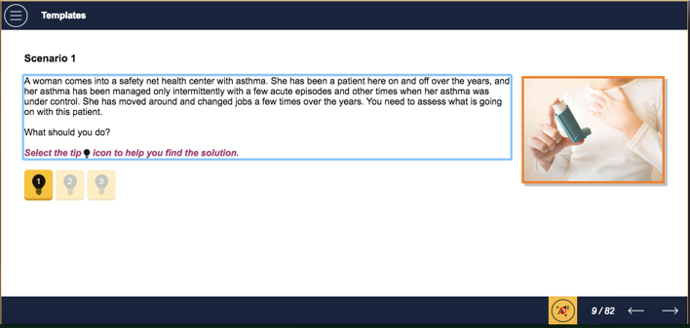

23 |  | Problem Statement 2: Inventory Turnover  How do you calculate inventory turnover?  Select the Tip icon to help you find the solution.  Tip 1:  Please review information on pages 349–350 in textbook.  Tip 2:  Please click on the link to observe calculation for inventory turnover.  How to calculate inventory turnover  https://www.tradegecko.com/learning-center/how-to-calculate-inventory-turnover  Tip 3:  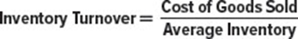
Image ID:
Alt Text:
 |  | Sample Template: Scenario_1
24 |  | Problem Statement 3: Inventory Methods  How do you calculate first-in, first-out (FIFO) periodic inventory?  Select the Tip icon to help you find the solution.  Tip 1:  Please review pages 341–342 in textbook.  Tip 2:  Please click on link to view FIFO inventory method.  First In First Out (FIFO) Method  https://pakaccountants.com/.../first-in-first-out-fifo-method  Tip 3:
Image ID:
Alt Text:
 |  | Sample Template: Scenario_1
25 |  | Problem Statement 4: Depreciation Methods  How do you calculate double-declining balance depreciation?  Select the Tip icon to help you find the solution.  Tip 1:  Please read pages 404–406 in the textbook.  Tip 2:  Please click on the link to view information on calculating double- declining balance depreciation.  Double Declining Balance Depreciation Calculator  https://www.calculatorsoup.com/calculators/financial/depreciation-declining-double.php  Tip 3:  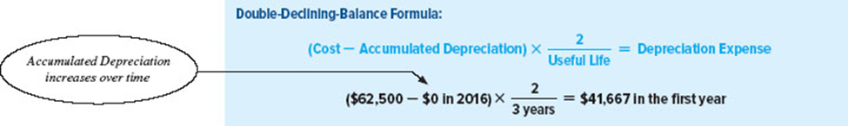
Image ID:
Alt Text:
 |  | Sample Template: Scenario_1
26 |  | Problem Statement 5: Depletion Of Natural Resources  How does the balance sheet show the economic value of a natural resource?  Select the Tip icon to help you find the solution.  Tip 1:  Please review pages 417–418 in the textbook.  Tip 2:  Please click on the link to view information about depletion.  Depletion  https://www.investopedia.com/terms/d/depletion.asp  Tip 3:
Image ID:
Alt Text:
 |  | Sample Template: Scenario_1
Summary
27 | In this module, you learned how to:  - Apply the cost principle to identify the amounts that should be included in inventory and the expense matching principle in order to determine cost of goods sold for typical retailers, wholesalers, and manufacturers  - Report inventory and cost of goods sold using the four inventory costing methods  - Evaluate inventory management using the inventory turnover ratio  - Understand methods for controlling inventory, analyze the effects of inventory errors on financial statements, and analyze the effects of inventory on cash flows  - Define, classify, and explain the nature of long-lived productive assets and interpret the fixed asset turnover ratio  - Apply the cost principle to measure the acquisition and maintenance of property, plant, and equipment  - Apply various cost allocation methods to assets that are held and used over time  - Apply measurement and reporting concepts for intangible assets and natural resources  - Explain how the acquisition, use, and disposal of long-lived assets impact cash flows
Image ID:
Alt Text:
 | Sample Template:
Review Questions
28 | What are the three manufacturing types of inventory?  Select all that apply.  - Raw materials inventory  - Work-in-process inventory  - Finished goods inventory  - None of the above  First incorrect response  That’s not correct. Please try again.  Second incorrect response  That’s not correct.  Correct response  Well done!
Image ID:
Alt Text:
Sample Template: CYU_MCQ_2
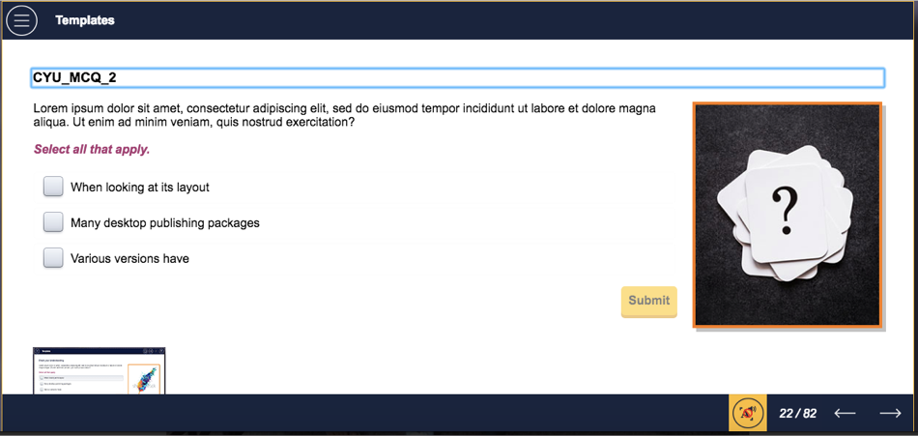

29 | What are the four generally accepted inventory costing methods available for determining cost of goods sold?  - Specific identification  - First-in, first-out (FIFO)  - Last-in, first-out (LIFO)  - Average cost  Select all that apply.  First incorrect response  That’s not correct. Please try again.  Second incorrect response  That’s not correct.  Correct response  Well done!
Image ID:
Alt Text:
 | Sample Template: CYU_MCQ_2
30 | What are some control features that focus on safeguarding inventories and providing up-to-date information for management decisions?  Select the correct answer.  - Keeping inventory accounting and physical handling of inventory responsibilities separate  - Theft- and damage-free storage of inventory  - Limiting access to inventory to authorized employees only.  - All of the above  First incorrect response  That’s not correct. Please try again.  Second incorrect response  That’s not correct.  Correct response  Well done!
Image ID:
Alt Text:
 | Sample Template: CYU_MCQ_1
31 | What are the three elements needed to calculate depreciation?  Select the correct answer.  - Acquisition cost, estimated useful life to company, and estimated residual value at end-of-life of the asset  - Overhead cost, holding cost, and inventory obsolescence cost  - Quantity demanded, volume per order, and carrying cost  - All of the above  First incorrect response  That’s not correct. Please try again.  Second incorrect response  That’s not correct.  Correct response  Well done!
Image ID:
Alt Text:
 | Sample Template: CYU_MCQ_1
32 | Name the three most widely used depreciation methods.  Select the correct answer.  - Straight-line, units-of-production, and declining-balance  - Percentage of completion, Accrual method, and full-cost method  - Tangible-asset method, single-incline method, and expense depreciation method  - All of the above  First incorrect response  That’s not correct. Please try again.  Second incorrect response  That’s not correct.  Correct response  Well done!
Image ID:
Alt Text:
 | Sample Template: CYU_MCQ_1
33 | What are the most common types of intangible assets ?  Select the correct answer.  - Goodwill (recognized in a business combination)  - Trademarks  - Copyrights  - All of the above  First incorrect response  That’s not correct. Please try again.  Second incorrect response  That’s not correct.  Correct response  Well done!
Image ID:
Alt Text:
 | Sample Template: CYU_MCQ_1
What’s Next
34 | In the next module we will discuss Reporting and Interpreting Stockholders’  Equity. Stockholders’ equity refers to the ownership of the business and the relationships within the equity section of the balance sheet.
Image ID:
Alt Text:
 | Sample Template:

